**Ten years after the crisis: Miscalibrating risk and the problem of governing a social network like a market.**

**INTRODUCTION**

As we write it is almost ten years since the collapse of the investment bank Lehman Brothers marked the start of one of the most significant financial crises and deepest recessions of our time. At the center of this crisis were collateralized debt obligations (CDOs) – then, a relatively unknown credit derivative with a notional value outstanding of $1.4trillion in 2007 (Yellen, 2013). By 2012 CDOs had lost on average 60% of their par value, and many were worthless (Cordell, Huang and Williams, 2012). The losses on CDOs paralyzed the global banking system, leading to the collapse or bailout of leading banks across the world and the imposition of huge social costs (Haldane & May, 2011). A failure of risk management was deemed to be at the heart of the CDO crisis (Financial Crisis Inquiry Commission (FCIC), 2011: xviii; US Senate, 2011: 12) which led to demands for increased transparency and a variety of risk-measuring refinements to reduce future failures (Mikes, 2011; US Senate, 2011: 12-14). But these demands did not generate the interventions that would prevent subsequent scandals, including Libor-rigging, money laundering and foreign exchange rate manipulation.

The continued failure of risk management in finance suggests something more fundamental is wrong with the way risk is conceived and risk mitigation is organized in financial services (see Munir, 2011). Much has been written about the systemic problems of bank interconnectedness, but interconnectedness alone should not impose harm if the securities which connect those organizations are robust. We accordingly revisit the 2008 crisis in credit derivatives in order to say something contemporary about the limits of existing conceptualizations of risk and risk management organization.

To do this we pivot from the demand side - how banks became systemically interconnected through the purchase of CDO securities that were too complex and risky, towards the supply side and the structuration of CDO securities. We attempt to bridge two literatures: those in critical accounting and organization studies which identify risk as a social construct and its management an organizational process (Hardy & Maguire, 2016; Gephart, Maanen & Oberlechner, 2009; Maguire & Hardy, 2009 & 2013; Miller, 2009; Power 2007 & 2009; Themsen & Skaerbaek, 2018) and sociological work which emphasizes the social embeddedness of economic activity at a meso level (Granovetter, 1985; Podolny & Page, 2003; Uzzi, 1997). From this we aim to say something novel about the sociological origins of risk management failure. Our central argument, drawing on traditional distinctions between market, hierarchy and network, is that the process of CDO structuration was originally organized to meet risks prospectively conceived of as market-based. This gave CDOs legitimacy allowing the activity to grow; but as it grew, the organizational relations of CDO structuration took a network-like rather than market-like form, which introduced different risks that reduced the efficacy of those market-framed risk control mechanisms. We understand this example of risk management failure as an organizational process, and we term this process ‘miscalibration’. We contend that this ongoing attempt to govern the sector as if it were a market when it organizes like a network, is a key cause of repeat risk management failure in financial services.

To make this argument a first section draws on the literature above to advance a social constructionist account of risk. A second section uses this approach to explain how the expert knowledge of financial economics came to understand risk in narrow terms as the opportunism that arises from information asymmetries in a context of market relations, notably ‘moral hazard’ and ‘adverse selection’. We show how this understanding shaped the organization of risk management: risk and safety were summonsed prospectively and became embodied in the risk-mitigating apparatus around CDO structuration where independent collateral managers played a central role. This created trust in, and the legitimacy of, the activity in the eyes of insiders and outsiders (Hutter & Power, 2005; Power, 2004 & 2007), allowing the activity to grow.

A third section examines why risk management failed. We draw on critical debates over the performativity of economics (Fleming & Banerjee 2016; Miller 2002) to emphasize the absence of ‘felicity conditions’ – the institutional, organizational and political circumstances which determine whether discourses exercise a binding performative power on their referents*.*We argue that risk management was calibrated to an imagined set of risks that emerge in market-like relations, only for the organization of CDO structuration to follow the historic tendency in other parts of the financial services sector to organize like a network (Baum, Rowley, Shipilov & Chuang, 2005; Sorenson & Stuart, 2001; Shipilov, 2006).

Our fourth section illustrates this network form by using social network analysis of our own self-built database of CDO structuration which shows that as the activity became larger, network relations consolidated, locking out new entrants. We also find that collateral managers – the key risk mitigating actor – were at the periphery of the network which reduced their structural capacity to influence network practice and perform the risk mitigating function allocated to them. We find that CDO quality deteriorates as the network consolidates. Triangulating this finding with official reports on the crisis we note the propensity for network-based risks of risk-blindness, groupthink and reciprocity which eroded margins of safety.

This study contributes to literature embedding risk studies in organizational research (Gephart et al., 2009; Power, 2007) and provides fresh organizational insights as to why risk-mitigating mechanisms fail (Marti & Scherer, 2016). It also has practical regulatory significance because it identifies active ‘social network risks’ on the supply side (rather than passive exposures on the demand side) as a core problem of risk management in finance.

**CONSTRUCTING RISK AS AN OBJECT**

**The Social Construction Of Risk**

Identifying and mitigating risk has become central to most organizational and market activities (Scheytt, Soin, Sahlin, Andersson & Power, 2006; Scott & Walshman, 2005), giving rise to increasingly complex systems of risk management (Power, 2007). Yet despite the heightened concern about risk and the increasing sophistication of risk mitigating mechanisms, systemic failures like that in credit derivatives in 2008 highlight gaps in our understanding of risk, its contexts and the capacity for risk management to misfire.

Risk can be viewed as something objectively given or subjectively constructed (Bromiley, Miller & Rau, 2006). Objectivist approaches conceptualize risk as external to the perceptions and actions of those actors tasked with identifying, measuring and responding to it (Lupton, 1999). This approach informs neo-classical and behavioral economics (Miller, 2009) as well as some organizational research which examines how collective processes lead to errors in risk measurement (March & Shapira, 1987; McNamara & Bromiley, 1997; Sinha, 1994; Sitkin & Pablo, 1992). But approaching risk as objectively-given has limitations when analyzing how risks come to be understood in periods of activity formation.[1] In such moments risks do not come pre-formed (Hutter & Power, 2005); they must be anticipated and constructed prospectively because they are inseparable from the relations and organizational structures yet to develop (Miller, 2009).

The prospective construction of risk takes place within social and cultural contexts of interpretation (Gephart, 2009: 144), which can be shaped by dominant discourses that reify and disseminate a particular view of risk (Maguire & Hardy, 2013). Such discourses rely on expert knowledge, which add shape and legitimacy to particular understandings of risk (Hardy & Maguire, 2016). These understandings of risk are institutionalized through ‘cultural circuits of capital’ such as programmes at leading business schools (Hall, 2008; Thrift, 2005) and are disseminated by epistemic communities such as consultants or economists who draw on such knowledge to frame problem definitions and propose solutions in organizational settings (Potter, 2005). In such circumstances, these discourses can assume a ‘truth-like’ status, displacing alternatives and constructing risk in common yet narrow ways across organizations (Phillips, Lawrence & Hardy, 2004). And can become hardwired into organizational processes when embedded in particular technologies of risk measurement and assessment which standardize methods of identifying, measuring and understanding of risk (Gerding, 2009; Hilgartner, 1992; Millo & MacKenzie, 2009). Each mechanism serves to create what Power (2004: 55) refers to as ‘the production of consent’ regarding risk and its management.

**CDO STRUCTURATION AS A MARKET**

The role played by the expert knowledge of financial economics in shaping the financial services sector is documented in a number of empirical studies (Beunza & Stark, 2004; Ferraro, Pfeffer & Sutton, 2005; Knorr-Cetina & Preda, 2006; Lounsbury & Hirsch, 2010; MacKenzie & Millo, 2003). CDOs were no exception in this regard – they formed part of the structured finance revolution that promised to minimize risk and create liquidity in key lending markets using complex financial models (Engelen et al., 2012). CDOs were asset-backed securities backed by the cash flows of, typically, sub-prime mortgage-backed securities (Duffie & Garleanu, 2001) which were paid to prioritized tiers or ‘tranches’ of CDO securities investors in sequence (see figure 1). These tranches were structured and priced using David X. Li’s Gaussian copula formula (MacKenzie, 2012; Salmon, 2009), so that the securities were, in a sense, an artefact of the expert knowledge embodied in the pricing technology.

(INSERT FIGURE 1 ABOUT HERE)

However financial economics also framed the way that risks were understood in CDO structuration and the organizational contexts within which those risks might arise (Roberts & Jones, 2009). Financial economists writing in academic, industry and policy publications interpreted risk narrowly as the potential harms that arise from information asymmetries present in bilateral market exchanges, which create incentives for opportunistic behavior (Bank for International Settlements, 2003; European Central Bank, 2004; Hull & White, 2004; IMF, 2006; Kiff & Mills, 2007; Watts, 2003 & 2004). The risks of adverse selection (the situation where an economic agent holds private knowledge about product quality that others do not), and moral hazard (where an economic agent enters into a risky exchange knowing that another party incurs the costs associated with that risk) became the central risks identified by financial economists. With adverse selection, it was argued banks would cherry-pick which assets to hold and which to package into the CDO when they possessed more private knowledge about collateral quality than investors (Duffie & Garleanu, 2001; Jobst, 2002). With moral hazard, it was claimed issuers had little incentive to locate and manage good quality assets or enforce contracts if investors bore all of the default risk (Duffie & Garleanu, 2001). A more general moral hazard fear about the risk of opportunism and fraud was also recognized (Gale, 2003).

Contrary to lay perceptions, organizing to minimize risk is a central feature of the financial services industry (MacKenzie & Spears, 2014; Millo & MacKenzie, 2009; Roberts & Jones, 2009). There are very strong commercial incentives as to why this is so (Lepinay, 2011). In CDO structuration, understandings of risk and safety therefore developed in parallel, so that industry organization came to embody prospective concerns about adverse selection and moral hazard risks. Independent collateral managers working on behalf of the investor (but selected by the IPs) were therefore tasked with selecting and often managing the assets that backed the CDO cashflows (Fabozzi & Goodman, 2001), thus notionally removing many adverse selection and moral hazard risks. It was argued that collateral manager independence encouraged IPs to supply assets with higher risk-weighted returns, and that collateral managers’ power to choose would drive out bad assets and the companies who built them (Hurst, 2000). Independent trustees, also working on behalf of the investor, were used to monitor collateral manager performance and ensure covenants were not breached in the process of selection and trading – adding an additional layer of security (DeMasi, 2007; Nealon, 1998).

These organizational risk-mitigating features complemented other devices, such as the subordination of management fees to investors’ cashflows and the issuer’s retention of the equity tranche (Choudhry & Fabozzi, 2003; DeMarzo, 2004). These mechanisms embodied a similar risk logic: to ensure market actors had ‘skin in the game’ and to assure investors that banks would not act opportunistically by exploiting market-based information asymmetries (Lewis, 2010: 143). The collateral manager was therefore central to assuaging investor fears about the risks of opportunism and thus fundamental to the growth of the activity (Gale, 2003). Their experience and skill was advertised in marketing publications sent to investors (Authors, n.d.) and their importance legitimized by credit rating agencies who made favorable adjustments to their CDO ratings to reflect collateral manager experience (Strumeyer, 2017: 365). Risk mitigating mechanisms were thus multi-faceted and self-reinforcing, summonsing risks prospectively in order to meet them organizationally.

**Why Risk Management Fails**

The prospective construction of risk in newly emerging activities gives form to particular risk-management practices and organizational arrangements (Power, 2007; Soin & Collier, 2013). They are essential forbuilding external trust and legitimacy in the organizations involved in an activity, and indeed in the activity itself (Meyer & Rowan, 1977). For example, the ‘over-the-counter’ (OTC) derivatives market would not have grown to its present size without ISDA Master Agreements which enshrined the depositing of collateral to minimize credit risks (Morgan, 2008). Similarly, the growth of consumer credit markets in the 2000s were built upon new credit scorecards like FICO which provided individualized measures of default risk (Poon, 2009).

However, although risk measurement and management provide legitimacy, those mechanisms can and do misfire, contributing to organizational (McMillan & Overall, 2017) and system-wide (Perrow, 1984 & 2010) failures. Organizational researchers identify at least four explanations as to why risk management fails. First, failures arise from *partiality*: risk management systems built on expert knowledge may fail if they do not fully engage with the extant practices that give rise to risks in a particular activity (Hopwood, 2013; McMillan & Overall, 2017; Miller et al., 2008). Second, failures arise from *conformity*: organizations can become over-reliant on expert knowledge leading to groupthink if homogenous collectives subscribe to the consensus view about activity risks and the correct means of addressing them (Fleming, Mingo & Chen, 2007; Janis, 1972; Uzzi & Spiro, 2005). Third, risks emerge from *complacency*: technologies of risk management may sedate vigilance towards risk by creating the illusion of control (Francis, 1994; Power, 2007). Studies of financial services highlight a fourth, *interactivity* or *counterperfomativity*: risk management processes may create unanticipated outcomes at a different scale, for example when micro-prudential risk management leads to the growth of systemic risk (Haldane & May, 2011; Pozner, Stimmler & Hirsch, 2010), or when technologies used to measure and minimize default correlation risks increase default correlation systemically (MacKenzie, 2011).

We wish to raise the possibility of a fifth: *miscalibration*. Miscalibration arises when risk management mechanisms are calibrated to an imagined set of future relations from which risks are assumed to arise, only for those relations to take a different form as the activity grows. Two debates inform this concept of miscalibration. The first is Miller’s (2002) critique of Callon (1998). Whereas Callon’s (1998) emphasis was on the felicity between expert discourses like economics and the economic world because the former formatted or ‘performed’ the latter, Miller (2002) questioned the performative capacity of such discourses when actors are embedded in multiple identities and ongoing relations subject to different, often conflicting, forms of framing. For Miller (2002) discourses like economics were ‘virtualist’ - a projection of how relations *ought* to be, which produced unintended consequences when they came into contact with other frames (Miller, 2002). Fleming and Banerjee (2016) extend this argument in their critical reflections on Spicer et al. (2009). Drawing on Austin (1962), they emphasize the importance of ‘felicity conditions’– the institutional, organizational and political circumstances which determine whether discourses exercise a binding performative power on their referents. They conclude that the performativity of any discourse is contingent upon an accumulation of supportive *a priori* or reiterated practices which may resist that discourse, or transform it as it is accommodated in practice (Fleming & Banerjee, 2016).

The failure of risk management as miscalibration concerns the conditions of *infelicity* -when a ‘projection of how relations ought to be’ meet ‘*a priori’s* and reiterated practices’ that do not accommodate those projections. Many empirical studies of the organization of financial services have emphasized the importance of network-based rather than market-based forms of co-ordination (Shipilov, 2006). Social networks have been shown to be important in syndicated loans (Sorenson & Stuart, 2001), underwriting (Baum et al., 2005) and in non-investment grade debt (Podolny, 1994). Social networks within finance have been known to improve efficiency through information exchange (Eccles & Crane, 1988), resource access (Hallen, 2008), or by improving coordination (Nooteboom, Berger & Noorderhaven, 1997; Saparito, Chen & Sapienza, 2004). Miscalibration, in this different relational context is a situation where risk management systems were designed to mitigate risks in *market*-like relations, causing unintended consequences when the activity, structurally and behaviorally, took the form of a *network*.

**Network Risks**

The distinction between market and network relations bridges the literature on the social embeddedness of economic activity (Granovetter, 1985; Podolny & Page, 2003; Uzzi, 1997) which recognizes that aggregate relations in an activity take different organizational forms (Miller et al., 2008; Powell, 1990). The sociality and social embeddedness of finance raises significant governance implications because different types of risk have been noted to arise from different relational and organizational forms (Hallikas, Karvonen, Pulkkinen, Virolainen & Tuominen 2004; Roberts & Jones, 2008). This literature notes that risks of opportunism are present in all forms of organization (Ring & Van de Ven, 1992; Liokas & Reuer, 2015), but network-based risks may be less informational and contractual in essence (Hellgren & Stjernberg, 1995; Jones & Lichtenstein, 2008; Starkey, Barnatt & Tempest, 2000; Windeler & Sydow, 2001). For example, because networks rely on mutual dependence and the collective pursuit of strategic goals (Powell, 1990), stronger relational ties may build dependencies that propagate and diffuse disturbances more quickly (Ebbers & Wijenberg, 2009). Information asymmetries or incentive distortions between two contracting nodes may therefore be of lesser risk than the pattern of relations across a network at the aggregate (Borgatti, 2005). Similarly, the capacity for individual actors, like collateral managers, to engage in purposeful and deliberate network-modifying action may be hampered if their position within the broader network structure is peripheral (Ahuja, Soda & Zaheer, 2012; Zaheer & Soda, 2009).

These features may be reinforced by cultural and sociological characteristics identified as arising in networks. Networks rely on knowledge sharing (Ghoshal & Moran, 1996; Josserand, 2004; Kogut & Zander, 1992), where ties are not formed fleetingly through price, but are embedded in social systems of repeat and reciprocal interactions (Granovetter, 1985; Podolny & Page, 2003; Uzzi, 1997). The ability of one actor to influence another may be constrained by historic interactions which diffuse and homogenize norms across a network, resulting in shared behavioral expectations that become difficult to adjust (Dyer & Nebeoka, 2000; Rowley, Behrens & Krackhardt, 2000). This social embeddedness may also create strong pressures to conform to particular network norms or risk reputational damage (Fleming et al., 2007; Perry-Smith & Manucio, 2017; Uzzi & Spiro, 2005). It may create rigidities (Lavie & Rosenkopf, 2006; Manning & Sydow, 2011; Sydow, Schreyogg & Koch, 2009) which increase the risk of standardization and groupthink, particularly when networks are closed and specialized (TerWal, Alexy, Block & Sandner, 2016), or encourage risk-taking and risk-blindness when it nurtures permissiveness rather than responsibility and trust (Edmondson, 1999).

Group-level dynamics pose quite different risks to those that appear within dyadic market relations (Albers, Schweiger & Gibb, 2015). The efficacy of any governance system grounded in an understanding of risk as market-based will be reduced if the organizational system that develops displays the complex relational characteristics of a network. Our next two sections will try to map these basic social relations in the process of CDO structuration using social network analysis.

**DATA SOURCES AND METHODS**

**Data Sources**

Our social network analysis draws on our self-built database of actors involved in the structuration of US$ denominated CDOs. The underlying data was harvested from *Offering Circulars* (OCs) – lengthy documents published and distributed by the IPs for a variety of users (investors, regulators, legal departments). OCs contain detailed descriptions of product structures, administration and the distribution of income as well as actors, which form our analysis of ‘roles[2]’.

We recognize that using secondary data has its limitations: we do not know the intricate details of the ties, their modality or the direction; but, nonetheless, we can construct a network of connections between actors. Based on the documentation available for each CDO in our database, we gathered information on agents involved in its structuration including attribute data such as the function in which the particular actor performs. This function is determined by the information received from CDO documentation which categorizes the particular activity for each actor, The key actors are: investment or commercial banks (the *IPs*) who structure and arrange the CDO deal, the *collateral manager* who selects and manages the underlying assets on behalf of the *issuer* (an off balance sheet special purpose vehicle (SPV), usually a wholly owned subsidiary of the IP) who then sells securities backed by the cashflows from these assets to *investors*. A *trustee* holds title to the assets of the CDO for the benefit of the investors (Tavakoli, 2008). There are also *legal representatives* to each party involved; plus *Irish listing and paying agents* who sell these securities on the Irish Stock Exchange for the benefit of institutional investors.

These positions were situated in particular institutional and regulatory domains for the purposes of regulatory arbitrage (Fligstein, 2001). For example for a US bank to sell CDO securities to a German bank, three international relations were established in parallel: i) a financing relation between the IP in New York and the issuer in Delaware to avoid the creation of a taxable event when assets (or asset risks[3]) are transferred (Tavakoli, 2008) ii) a transfer of assets (or asset risks) between the issuer in Delaware and the co-issuer (another SPV) in the Cayman Islands to further reduce regulatory costs, and iii) a marketing relation between the co-issuer in the Caymans and the listing agent on the Irish Stock Exchange to trigger the *Quoted Eurobond Exemption* rules which reduced tax payable on interest[4] (Arthur Cox, 2013: 3). Regulatory arbitrage was essential because margins on CDOs were so slim (Tavakoli, 2006). Without the tax and regulatory cost savings, it is unlikely many CDOs would ever have been built at all.

These documents were sourced from a variety of places including the Senate’s Financial Crisis Inquiry Commission (FCIC, 2011) investigation into the subprime crisis, the Irish Stock Exchange databank and other online repositories. Overall our dataset contains 373 unique US-created CDOs issued in USD between 2001 and 2008. The frequency of OCs from which we populated our database was dependent on data availability but mirrors the pattern of originations disclosed by the Securities Industry and Financial Markets Association (SIFMA, 2016) (Figure 2). The database contains a total of 361 unique firms involved in the US CDO structuration process, the breakdown of which is in Figure 3. Although actors generally perform one supply-side service, there are notable exceptions – for example some firms are involved in both trustee and administrative services. In those circumstances firms were allocated to the function they were most involved in.

(INSERT FIGURE 2 and 3 ABOUT HERE)

**Methods And Methodology**

We use social network methods to explore the architecture of social relations in CDO structuration, specifically whether they are market-like or network-like. We draw on theoretical and empirical work to triangulate our social network analysis from official investigative reports on the crisis (FCIC, 2011; Federal Reserve Bank of New York, 2014; US Senate, 2011). We are therefore able to say something more substantive about the relationships between agents, and the unanticipated risks that arise from miscalibration as the activity evolved.

Utilizing network analysis methods is not necessarily a positivist exercise; it is not an attempt to assert causality. Rather, by constructing a simple network structure we can draw out the complex interactions between actors over time; and it enables us to contextualize and locate risk mitigation organization and allows us to illustrate how it fails in networks. Using our database, we created a binary two-mode matrix which includes firms involved in the structuration (vertical axis) and the CDOs (horizontal axis). But because we are interested in how the supply-side agents are connected to each other, the initial matrix is transformed into a one-mode matrix. This effectively omits the CDO from the networks but provides us with a far more informative picture and therefore clearer understanding of how actors involved in the structuration of CDOs are connected to one another. The values for each pair of nodes represent the pair-wise ‘co-membership’ in the creation of a CDO (“3” represent ties *j* and *k* jointly structure three CDOs). It is this co-membership network which informs our network approach as it is these enduring relationships that separate a market from a network.

Not sure if this is any use: I can also create network images for these

Table 1a & 1b: Illustration of coding for two-mode and one-mode network

|  |  |  |  |  |  |  |  |  |  |  |  |  |  |  |  |
| --- | --- | --- | --- | --- | --- | --- | --- | --- | --- | --- | --- | --- | --- | --- | --- |
|  | CDO 1 | CDO 2 | CDO 3 |  |  | Agent 1 | Agent 2 | Agent 3 | Agent 4 | Agent 5 | Agent 6 | Agent 7 | Agent 8 | Agent 9 | Agent 10 |
| Agent 1 | 1 | 1 | 1 |  | Agent 1 | - | 2 | 2 | 2 | 3 | 1 | 2 | 2 | 1 | 1 |
| Agent 2 | 1 | 0 | 1 |  | Agent 2 | 2 | - | 2 | 1 | 2 | 0 | 1 | 1 | 1 | 1 |
| Agent 3 | 1 | 0 | 1 |  | Agent 3 | 2 | 2 | - | 1 | 2 | 0 | 1 | 1 | 1 | 1 |
| Agent 4 | 1 | 1 | 0 |  | Agent 4 | 2 | 1 | 1 | - | 2 | 1 | 1 | 1 | 0 | 0 |
| Agent 5 | 1 | 1 | 1 |  | Agent 5 | 3 | 2 | 2 | 2 | - | 1 | 2 | 2 | 1 | 1 |
| Agent 6 | 0 | 1 | 0 |  | Agent 6 | 1 | 0 | 0 | 1 | 1 | - | 1 | 1 | 0 | 0 |
| Agent 7 | 0 | 1 | 1 |  | Agent 7 | 2 | 1 | 1 | 1 | 2 | 1 | - | 2 | 1 | 1 |
| Agent 8 | 0 | 1 | 1 |  | Agent 8 | 2 | 1 | 1 | 1 | 2 | 1 | 2 | - | 1 | 1 |
| Agent 9 | 0 | 0 | 1 |  | Agent 9 | 1 | 1 | 1 | 0 | 1 | 0 | 1 | 1 | - | 1 |
| Agent 10 | 0 | 0 | 1 |  | Agent 10 | 1 | 1 | 1 | 0 | 1 | 0 | 1 | 1 | 1 | - |

Our network analysis seeks first to explore the overall structure of the activity, examining concentration by ‘role’-and how this pattern reflects the social construction of risk. This is done by looking at basic properties of the network including distribution of actors per function and across the network overall by measuring degree centrality. Degree centrality is a measure of the actor’s popularity in the network and in our case represents the number of times an actor actively participates in the structuration of a CDO. For undirected networks, degree centrality tends to be highly correlated to other measures of centrality (betweeness, closeness and eigenvector), hence this simple measure is sufficient here (Valente et al 2008).

Second, we analyze the activity longitudinally to explore the extent to which the pattern of relationships exhibit market-like or network-like properties over time. Initially we compare changes for each function by counting the number of individual firms active per year. An increase in these figures proposes entrants of new actors within specific function, which we would expect in an activity that is market-like. To assess network properties of the activity by examining network positions of actors for each year. We do this by separating the initial matrix, which includes activity between 2001 and 2008, into matrices for each component year. We can assess changes to the network structure over time by running a QAP correlation which is principally used to identify similarities or differences between networks (Borgatti et al. (2018). Highly correlated matrices indicate a consolidation of activity as structure becomes more similar, whereas a low correlation would promote the idea of a fragmented structure.

Finally we use core-periphery (C/P) analysis to analyze how the particular market-based risk mitigating mechanisms in CDO structuration may have contributed to the crisis when applied in a network. We apply the continuous C/P method described by Borgatti and Everett (1999) to distinguish core actors – actors closely connected to each other – from those in the periphery – actors loosely connected to each but lack cohesion with the core. Apart from the recommended core size and positioning of actors in either core or periphery (which is visualized using multi-dimensional scaling) (Borgatti et al. 2018), the Gini-coefficient and heterogeneity provide further detail on the equality of nodes within this structure and the distribution of scores across the population. Given the longitudinal nature of the network, we computed C/P for yearly datasets to provide further detail on change and stability of the core over time. In doing so we provide an alternative view of how risk is managed in this activity: a network context in which to situate risk and uncertainty as constructed through social relationships between actors. This provides us with the context in which to understand the failure of risk management: rather than a market, the consolidation of these network relations over time through repeat interactions was masked by an assumed diversification effect of more providers of supply-side services becoming involved. This was previously not looked at, but rather, it was assumed, and whilst these product-based networks have created the same type of products, their macro-network positions may have enabled them to utilise network relations for darker reasons; to create outcomes that circumvent risk-mitigating structures.

**FINDINGS AND DISCUSSION**

**How The Social Construction Of Risk Shapes Network Organization**

In terms of concentration, our actor degree distribution (i.e. how many times an actor is involved in the structuration of a CDO) shows considerable variation. In our dataset, 51.8% (187 of the 361) of actors are involved in the structuration of individual CDOs only once or twice and over 80% of actors are involved in less than ten CDOs. However, there is also significant concentration: 5.5% (20 of the 361) of actors are involved in the structuration of more than 50 CDOs (Figure 4). The frequency of actor involvement depends on their role (Figure 5). Collateral management is the most uneven: of the 149 collateral managers in our dataset, the majority manage either one CDO (69 collateral managers) or two CDOs (33 collateral managers). IPs, are more concentrated; although not all US banks are equally involved in CDO structuration. Merrill Lynch is the most prominent IP in our sample (supporting anecdotal evidence in Lewis 2010), involved in 84 CDOs, followed by Goldman Sachs with 39 and Citigroup with 35 CDOs. Administrative support functions where experience is valued like *trustees* are highly concentrated, with a small number of well-established firms (for example, JP Morgan, LaSalle Bank and Wells Fargo) active in a larger number of CDOs.

(INSERT FIGURE 4 and 5 ABOUT HERE)

The relationship between IP and collateral manager is the central focus of risk management in the literature discussed above, and the frequency patterns are suggestive of market-like relations. There is little scholarly research on this relation, but empirical work suggests relations were not market-like. Collateral managers were not wholly free to select assets from a ‘market’. They often relied on the extension of credit facilities by banks to purchase assets that backed CDOs during the ‘ramp up’ period (Lancaster, Schultz & Fabozzi, 2008:182). Those ‘ramp lines’ often came with conditions as to what assets could be bought for the CDO - collateral managers were presented with a cut-down list of securities by the IP, from which they then made their selections (US Senate, 2011: 565). Second, collateral managers were selected by banks, not investors. The selection process could involve quite complex and sensitive discussions within banks about the need to balance reputational risk if relations were perceived to be too close (Scott & Walshman, 2005), with the preference for collateral managers who were ‘easy to work with’ (US Senate, 2011: 564). Recommendations for appropriate collateral managers were sought from professional and personal contacts (ibid: 564), illustrating the role of network transitivity rather than market price in coordinating relations. Although in this case transitivity was driven as much by the need to balance the demonstration of separateness with the practical need to find partners of ‘good fit’, who understood ‘the rules[5]’ (ibid 565).

This different pattern of involvement is the outcome of two processes. First, it is the consequence of the way risk was socially constructed at the point of activity formation (Power, 2007), specifically the focus on adverse selection and moral hazard. Strong, repeat ties between collateral managers and IPs would create suspicion of collusion. As a consequence, with a small number of exceptions, individual collateral managers were used only once or twice by the same bank in the process of structuration. Second, logically, the fragmentation of the collateral managers is the corollary of concentration at the level of the IP - the frequency patterns are interdependent. It should be noted that the concentration of IPs is not purely reflective of concentration in banking more generally; many banks did not become involved in CDOs as IPs, and non-bank firms like Fortis and ICP could – and did – act as CDO IPs, but did not become central. There are particular network reasons why this is so, which we will now explain.

**Embeddedness, Reciprocity And Risk-Blindness**

Our network analysis shows that core IPs in the network were formed of a small number of banks, who maintained that position in the network over time. The five IPs most significantly involved in the CDO market claimed 42%, 45% and 41% of the IP activity in 2005, 2006 and 2007 respectively; and whilst there is some movement in and out of the top five core firms - large commercial banks like JP Morgan, Wells Fargo, Wachovia, Bank of America (the largest US banks at that time, by assets) did not grow to dominate the activity or displace the original incumbents, despite significant growth in the activity after 2005 (Table 1).

This positional embeddedness is a consequence of their relational embeddedness, emphasizing the networked basis of co-ordination in CDOs. The number of actors involved in the network increases over time as the activity grows, but this has little effect on the structure of network relations. Figure 6 shows that the network becomes *more*, not less, similar over time: the correlation between network structures is highest (0.84) for the years 2006 and 2007, the years with the highest number of active firms. Network relations, in other words, *consolidate* in a period of growth, despite the emergence of new entrants. This is not what we would expect to see in a market. Growth and product innovation should have increased access opportunities for new entrants with different skills (Powell, Koput & Smith-Doerr, 1996; Ahuja, 2000). Yet relationships endure despite the presence of alternatives (see Krackhardt, 2003). One explanation could be that individual incumbents had a knowledge based advantage. But although the mathematics of these securities were complex, the Gaussian copula models used to structure these securities could be reverse engineered from credit rating agency models (Gerding, 2009; Lucas, Goodman & Fabozzi, 2007) and were comprehensible to many PhD students with a mathematics, engineering and finance background (MacKenzie & Spears, 2014). Ties may have developed as a result of a shared culture of practice (MacKenzie, 2011). That may explain the separation between the organizational silos of CDO structuration and mortgage backed security structuration, butcannot explain the enduring presence of some banks in this activity to the exclusion of others.

The most convincing explanation is that pre-existing relations acted as a barrier to entry. Mutual learning (Baum et al., 2005; Lioukas & Reuer, 2015) and reciprocity (Jensen, 2003; Kenis & Knoke, 2002) within the network created something akin to ‘project-based’ competences, which restricted new entrants (Manning & Sydow, 2011). As the activity grew in scale, relations consolidated isomorphically as the value of existing relations between nodes, for each node, increased– locking out competition. In his FCIC submission, Nestor Dominguez, co-head of Citigroup’s CDO desk, confirmed as much when he noted that only a small number of banks like Citi had the requisite network relations to perform certain activities, such as write CDO liquidity puts (FCIC, 2011: 139).

This form of closure introduced network-based rather than market-based risks, such as rigidity, conformity and groupthink (Sorenson &Waguespack, 2006; TerWal et al., 2016). Actors were insensitive to the problems of homogeneity and scale building in the system, which Haldane and May (2011) identified as central to the collapse of CDOs. A sense of ‘comfort’ not ‘safety’ was nurtured (Edmondson, 1999) which cultivated the ‘pervasive permissiveness’ identified by the FCIC as the cultural foundation of the crisis (FCIC, 2011: xvii). As Uzzi (1997) notes, repeat exchanges lead to systems of reciprocity which improve the terms of trade. Improved terms in a context of permissiveness practically meant a growing tolerance for leverage (FCIC, 2011: xxiv), an acceptance of riskier collateral (FCIC, 2011: 4,166) and discretion in interpreting model outputs which measure risk and structure CDO securities (US Senate, 2011: 295). Griffin and Tang (2012), for example, reverse engineered the credit rating models used to structure CDOs and found that there was much more AAA-rated paper in the market than was accountable by those models. They also found that those CDOs with the greatest discretionary adjustments had their credit ratings downgraded further post-crisis. These darker forms of reciprocity led to the normalization of favors and misconduct, typical in other industry examples (see Ashforth & Anand, 2003; Lampel, 2004). The emails disclosed in the US Senate report reveals a willingness for actors in different network positions to make concessions to maintain contacts and retain positions of connectedness that boosted deal earnings. This was true of loan suppliers (US Senate, 2011: 139), banks (ibid: 515, 532, 553), collateral managers (ibid: 598), underwriters and placement agents (ibid: 324) and credit rating agencies (ibid: 274, 281).

Reciprocity improved terms of trade but degraded standards over time. This was borne out in the finding that post-crisis credit rating writedowns correlated with vintage (the year each CDO was structured) rather than product type (Cordell et al., 2012). Favors within the network not only added risks, but reduced costs for network incumbents which acted as a barrier to new entrants - creating something akin to a ‘market for lemons’ where the bad practices and products drove out the good (Akerlof, 1970) – the opposite of what was expected by the introduction of collateral managers. This process of concession-making, favor exchange and network closure provides some insight into the micro-organizational context for Minsky’s (1982) financial instability thesis that periods of financial stability lead to the gradual erosion of the margins or ‘cushions’ of safety (see Kregel, 2008). “I think if you look at the results of what happened on Wall Street, it became, ‘Well, this one’s doing it, so how can I not do it, if I don’t do it, then the people are going to leave my place and go someplace else.’” Managing risk “became less of an important function in a broad base of companies, I would guess.” (FCIC: 63-4)

(INSERT TABLE 1 AND FIGURE 6 ABOUT HERE)

**The Centrality Of CDO Administration And Its Standardizing Effects**

A small number of embedded firms could, theoretically, construct a diversity of products which compete for investors. And there is some evidence that there were many changes to CDO structures in the period we examine (see Authors, 2011 for a review). But these product changes did not amount to the creation of a ‘market’ with products that embodied significantly different properties. Beneath the apparent changes and diversity there were also regularities linked to the economics of the product. In CDO, profits were made on the spread between the yield paid on the securities that backed the CDO and the interest incurred on the CDO securities issued, and the arbitrage of regulatory systems to minimize taxation costs, capital requirements and disclosure (Partnoy, 2010; Pozsar, Adrian, Ashcraft & Boesky, 2010; Kroszner & Strahan, 2011).

The former required a standardization of contracts which allowed the activity to scale up (Riles, 2011; Watts, 2004). In the early 2000s CDO activity growth had been hampered by the use of *ad hoc* contracts, particularly in CDS markets, which were crucial to the development of cost effective/capital efficient synthetic CDOs. In 2003, the International Swaps and Derivatives Association (ISDA) developed standardized contracts which allowed credit rating agencies to apply a single figure in their Gaussian copula model to measure default correlation across different assets, allowing the sector to grow more rapidly (Chen, Cifuentes, Desai & Ray, 2005; MacKenzie, 2010).

In terms of the latter, this standardization had an organizational corollary.As contracts became standardized and models increased conformity, the CDO administrative infrastructure in the network became the core ‘core’ of the network. In terms of degree centrality (the number of ties one node has to others), the most central actors in our dataset are the Delawarian registrar to the co-issuer, Puglisi and Associates - a small accounting and administrative services firm established by a former finance professor at the University of Delaware, which is involved in 79% of all 373 CDOs in our sample; followed by law firms Maples and Calder and Walkers who act as Cayman-based registrars and legal advisors in 58% and 35% of those CDOs respectively (Table 2). Thus, despite surface level innovations, there were strong(social) network regularities (Perry-Smith & Manucio, 2017) as product and network reinforced each other isomorphically: the domicility of these core administrative actors was central to the regulatory arbitrage of the product; whilst the skills developed in those core firms in those domicilities placed constraints on the form of innovation at the level of the product. This symbiosis created narrow innovation and rigidities that meant product and network became increasingly homogeneous, despite superficial differences (see Gersch, Goeke & Wessel, 2009; Sydow, 2009; Lavie & Rosenkopf, 2006; Manning & Sydow, 2011).

(INSERT TABLE 2 ABOUT HERE)

**Core-Periphery and The Core-Core**

The final aspect of our network analysis involves the relation between the collateral managers and the IPs in the context of a network rather than a market. The C/P analysis of the combined network exhibits a ‘dense, cohesive core and a sparse, unconnected periphery’ (Borgatti & Everett, 1999: 375) containing 19 nodes at a correlation of .867 indicating a good fit for the C/P model (ibid). The Gini-Coefficient of .752 and actor heterogeneity of 0.019 further suggest that ties between actors across the network are distributed very unequally (Figure 7). Members of the core, also exhibit the tendency to remain core members throughout the emergence of the CDO bubble market, whereas others only enter the core for selected years after 2004 (Figure 8). Finally, whilst the core expands in terms of numbers, it shrinks in relative terms as CDO activity grows (Figure 9), implying a consolidation of relations and activities, reinforcing the structural position of incumbents in the core and leading to a growing fragmentation at the periphery.

(INSERT FIGURES 7, 8, 9 ABOUT HERE)

This strong core-periphery structure illuminates one significant but overlooked explanation for the crisis. The interaction between the network and the product created conformity across assets, and systems of reciprocity within the network led to an erosion of safety margins in those assets over time, whilst the cultural processes of groupthink and risk-blindness hampered understandings of consequences. The core-periphery structure of the network indicates that no matter how arms-length collateral managers kept their relations with IPs, they were selecting and managing securities that were relatively homogeneous, where the underlying collateral deteriorated over time. There was therefore, in effect, no real benefit to the independent selection and management of assets by collateral managers. Indeed, our network analysis highlights a paradox: the peripheral position of collateral managers is a function of the need to be seen to be distant from the banks. This may mitigate market-based risks, but in a network it robs collateral managers of the structural power to exercise voice or exit pressures on banks, in Hirschman’s (1970) terminology. They have neither the authority to encourage banks to offer better quality/lower risk CDO securities, nor the capacity to influence collateral quality by refusing to buy, because with so many other collateral managers in the activity area, there was always another collateral manager willing to take their place. Consequently, managing risk as something that arises in markets rather than networks may have contributed to the crisis, if only that it sedated the normal sensitivities to risk had investors bought securities directly from the IPs.

**CONCLUSION**

This paper has shown the role of expert knowledge (Hardy & Maguire, 2016), specifically financial economics, in framing risk in CDO structuration as a problem of adverse selection and moral hazard in bilateral market exchanges. This discursive construction shaped the organization of the activity (Maguire & Hardy, 2013; Power, 2007) as independent collateral managers were integrated into the process of structuration to minimize the risks that IPs would use CDO vehicles to offload undesirable assets. Drawing on traditional organizational distinctions between market, hierarchy and network, we argued that the process of CDO structuration was organized to meet putative risks conceived of as market-based. This gave the activity legitimacy allowing it to grow, but as it grew relations became ‘network-like’, reducing the efficacy of those market-framed risk mitigating mechanisms. We term this process ‘miscalibration’.

To make this argument we presented a social network analysis of our self-built database of 373 US$ denominated CDOs. We identified four problems. First, a problem of *concentration*. A desire to avoid the impression of collusion between collateral managers and IPs/banks, meant the frequency of involvement for each became inversely related: the consequence of IP concentration was a fragmentation of collateral management. This gave IPs power to impose restrictions on collateral managers’ asset selection options. Second, the concentration of IPs was caused by their social and economic *embeddedness* within the network. Those IPs present and core in the early stages of market formation remained core and the structure of network relations consolidated during this growth phase, despite the entry of new actors. We argue a form of isomorphism was at work: as opportunities expanded, the value of existing relations between nodes, for each node, increased so that embedded (social) ties between key actors acted as a barrier to entry (Granovetter, 1973). This led to problems of groupthink and risk-blindness (FCIC, 2011; US Senate, 2011); whilst the propensity for repeat relations to improve the terms of trade (Uzzi, 1997) led to systems of reciprocity within closed relations which nurtured a culture of permissiveness (Edmondson, 1999; TerWal et al., 2106) and ultimately misconduct (Federal Reserve Bank of New York, 2014).

Third, we explain the *absence of diversity* at the level of the CDO product and the structuration process. The necessity of regulatory arbitrage to the economics of the CDO generated administrative roles in domicilities which minimized regulatory and disclosure costs. Firms within those domicilities became core to the network and shaped the future trajectory of innovation. This created a problem of homogeneity. Finally, the network exhibited a strong core-periphery structure, with collateral managers predominantly in the periphery. Their fragmentation and peripherality meant they could exercise neither ‘voice’ nor ‘exit’ pressures to change network practice. Collateral managers could only select increasingly homogeneous assets of declining quality put together by a relatively small group of core firms in the network. The benefits to diversification or active management of those assets, therefore, were largely ineffectual. This organizational feature may have played some role in the crisis, even if it was only to sedate the normal sensitivities to risk had investors bought securities directly from the IPs.

To our knowledge this study is the first of its kind to outline the US$ CDO structuration process in the run up to the financial crisis of 2008, and so makes a vital empirical contribution to the study of organization in financial services, and the role of organization in crisis. In terms of theory, this paper adds to the ongoing theorization of risk in studies of organization, specifically the role of expert knowledge and dominant discourses in constructing risk and risk management mechanisms. Our contribution is to conceptualize risk management failure as a form of miscalibration between organizational forms, and so should be read as a *retrospective* construction of risk, one which acknowledges a role for organizational analysts in making different risks visible which would not have been considered without our interventions (Marti & Scherer, 2016). This may open up future research on forms of risk management failure from a social constructionist perspective.

Second, we contribute to the theory of risk in financial networks. Whilst the idea that financial risks are organized like a network is not without precedent (Haldane & May, 2011; Markose, Giansante & Shaghaghi, 2012), most of these studies focus on interconnectedness and demand side exposures to particular securities. This study is among the first to examine the organization of structuration on the supply side as a source of risk - interconnectedness poses greater potential harm if the securities which underlie those relations carry unacknowledged risks. To understand those risks it is important to analyze the relational form and practices which underpin their structuration on the supply side. This study provides the theoretical and empirical micro-foundations for Minsky’s (1982) macro argument about the gradual erosion of ‘cushions of safety’. Alongside existing theories of systemic risk, ‘social network risk’ and the darker side of reciprocity have the capacity to augment our understanding of why finance appears to be so fragile, so often.

These two theoretical contributions have practical applications. Most immediately, if networks are the organizational form by which financial services tend to organize, why not govern them as such? Acknowledging, and prospectively organizing for, ‘social network risks’ on the supply side may lead to more effective regulation and oversight over time. This would imply an important role for organizational analysts in risk management. Recognizing the social embeddedness of economic activity may mean we avoid future crises where risks are treated as arising in market-like relations, but emerge from network-like relations.

**References**

Ahuja, G. (2000). Collaboration networks, structural holes, and innovation: A longitudinal study. *Administrative Science Quarterly*, *45*, 425–455.

Ahuja, G., Soda, G., & Zaheer, A. (2012). The genesis and dynamics of organizational networks. *Organization Science*, *23*, 434-448.

Akerlof, G. (1970). The market for lemons. *Quarterly Journal of Economics,* *84*, 488–500.

Albers, S., Schweiger, B. & Gibb, J. (2015). Complexity, power and timing in multipartner alliances: An integrative review and research agenda. In Das, T. K. (Ed.), *Managing multipartner strategic alliances*: pp. 57-87. New York: Information Age Publishing.

Arthur Cox (2013). *Specialist Debt Securities – Listing on the Irish Stock Exchange*. Dublin: Arthur Cox Listing Services Limited.

Ashforth, B. E. & Anand, V. (2003). The normalization of corruption in organizations. *Research in Organizational Behavior*, *25*, 1-52.

Austin, J.L. (1962). *How to do things with words*. Oxford, UK: The Clarendon Press.

Authors (2010), (2011), n.d.

Baum, J.A.C., Rowley, T.J.,Shipilov, A.V. & Chuang, Y.-T. (2005). Dancing with strangers: Aspiration performance and the search for underwriting syndicate partners. *Administrative Science Quarterly*, *50*, 536–575.

Beunza, D. & Stark, D. (2004). Tools of the trade: The socio-technology of arbitrage in a Wall Street trading room. *Industrial and Corporate Change*, *13*, 369–400.

Bank for International Settlements (2003). *Credit risk transfer: Report*. Basel: Bank for International Settlements.

Borgatti, S. P. & Everett, M. (1999). Models of core/periphery structures. *Social Networks*, *21*, 375-395.

Borgatti, S.P. (2005). Centrality and network flow. *Social Networks,* *27*, 55–71.

Bromiley, P., Miller, K., & Rau, D. (2006). Risk in strategic management research. In: Hitt, M.A., Freeman, R.E., Harrison, J. (Eds.), *The Blackwell handbook of strategic management*, pp. 259-288. Oxford: Blackwell Publishing Ltd.

Callon, M. (1998). Introduction: the embeddedness of economic markets in economics. *The Sociological Review,* *46*, 1–57.

Chen, N., Cifuentes, A., Desai, M. & Ray, A. (2005). *The young and the restless: Correlation drama at the big three rating agencies*, Wachovia Securities 22/02/2005

Choudhry, M. & Fabozzi, F. J. (2003). Originating collateralized debt obligations for balance sheet management. *Journal of Structured and Project Finance,* 9, 32–52.

Cordell, L., Huang, Y. & Williams, M. (2012). *Collateral damage: Sizing and assessing the subprime CDO crisis.* Working Paper no. 11-30/R, Philadelphia, PA: Federal Reserve Bank of Philadelphia.

DeMarzo, P. M. (2005). The pooling and tranching of securities: A model of informed intermediation. *The Review of Financial Studies,* *18*, 1–35.

DeMasi, J., (2007). An overview of collateralized debt obligations. *Community Banker*, *16*(7), 50-52.

Duffie, D. & Garleanu, N. (2001). Risk and valuation of collaterized debt obligations. *Financial Analysts Journal*, *57*, 41-59.

Dyer, J. H. & Nobeoka, K. (2000). Creating and managing a high-performance knowledge-sharing network: The Toyota case. *Strategic Management Journal*, *21*, 345-367.

Ebbers, J.J. & Wijnberg, N. M. (2017). Betwixt and between: Role conflict, role ambiguity and role definition in project-based dual-leadership structures. *Human Relations, 70*(11), 1342-1365.

European Central Bank. (2004). *Credit risk transfer by EU banks: activities, risks and risk management*. Frankfurt am Main: European Central Bank.

Eccles, R. G. & Crane, D. B. (1988). *Doing deals: Investment banks at work*. Boston: Harvard Business Review Press.

Edmondson, A. (1999). Psychological safety and learning behavior in work teams. *Administrative Science Quarterly,* *44*, 350–383.

Engelen et al., (2012).

Fabozzi, F. & Goodman, L. S. (2001). *Investing in collateralized debt obligations*. Hoboken: John Wiley and Sons.

Federal Reserve Bank of New York (2014). *Enhancing financial stability by improving culture in the financial services industry*, New York: Federal Reserve Bank of New York.

Ferraro, F., Pfeffer, J., & Sutton, R. I. 2005. Economics language and assumptions: How theories can become self-fulfilling. *Academy of Management Review*, *30*, 8–24.

FCIC (2011). *The financial crisis inquiry report*. (http://fcic-static.law.stanford.edu/cdn_media/fcic-reports/fcic_final_report_full.pdf).

Fleming, P. & Banerjee, S.B. (2016). When performativity fails: Implications for critical management studies. *Human Relations,* *69*, 257–276.

Fleming, L., Mingo, S., & Chen, D. (2007). Collaborative brokerage, generative creativity, and creative success. *Administrative Science Quarterly*, *52*, 443–475.

Fligstein, N. (2001). Social skill and the theory of fields. *Sociological Theory*, *19*, 105-125.

Francis, J.R. (1994). Auditing, hermeneutics and subjectivity**.***Accounting, Organizations and Society*, *19* (1994), 235-269

Gale, S. (2003). Who guards the guards? *Trade Finance*, July: 28–30.

Gephart, R.P., Van Maanen, J. & Oberlechner, T. (2009). Organizations and risk in late modernity. *Organization Studies* *30*, 141–155.

Gerding, E.F., (2009). Code, crash, and open source: The outsourcing of financial regulation to risk models and the global financial crisis. *Washington Law Review*, *84*, 127–198.

Gersch, Goeke & Wessel, 2009

Ghoshal, S., & Moran, P. (1996). Bad for practice: A critique of the transaction cost theory. *Academy of Management Review*, *21*, 13-47.

Granovetter, M. S. (1973). The strength of weak ties. *American Journal of Sociology*, *78*, 1360-1380.

Granovetter, M. S. (1985). Economic action and social structure: The problem of embeddedness. *American Journal of Sociology*, *91*, 481-510.

Griffin, J. M. & Tang, D. Y. (2012). Did subjectivity play a role in CDO credit ratings? *Journal of Finance, 67*, 1293–1328.

Haldane, A. G. & May, R. 2011. Systemic risk in banking ecosystems*. Nature,* 469: 351–355.

Hall, S. (2008). Geographies of business education: MBA programmes, reflexive business schools and the cultural circuit of capital. *Transactions of the Institute of British Geographers,* *33*, 27–41.

Hallen, B.L. (2008). The causes and consequences of the initial network positions of new organizations: From whom do entrepreneurs receive investments? *Administrative Science Quarterly*, *53*, 685–718.

Hallikas, J., Karvonen, I., Pulkkinen, U., Virolainen, V.-M. & Tuominen, M. (2004). Risk management processes in supplier networks. *International Journal of Production Economics, Investment and Risk,* *90*, 47–58.

Hardy, C. & Maguire, S. (2016). Organizing risk: Discourse, power, and “riskification”. *Academy of Management Review*, *41*, 80–108.

Hellgren, B. & Stjernberg, T. (1995). Design and implementation in major investments — A project network approach. *Scandinavian Journal of Management, 11*, 377–394.

Hilgartner, S., (1992). The social construction of risk objects: Or, how to pry open networks of risk. In Short, J. F. & Clarke L. (Eds.) *Organizations, uncertainties and risk*, pp. 39–5, Boulder: Westview Press.

Hirschman, A. O. (1970). *Exit, voice, and loyalty: Responses to decline in firms, organizations, and states*. Cambridge: Harvard University Press.

Hopwood, A. G. (2013). The Economic Crisis and Accounting: Implications for the research community. *Accounting, Organization and Society*, *34*, 797-802.

Hull, J. D. & White, A. (2004). Valuation of a CDO and an nth to default CDS without Monte Carlo simulation. *Journal of Derivatives*, *12*(2), 2-33.

Hurst, R. R. (2000). Collateralized debt obligations (CDOs): Identity crisis. *Securitization Conduit*, *3*, 17–37.

Hutter, B. & Power, M. (2005). *Organizational encounters with risk*. Cambridge: Cambridge University Press.

IMF (2006)

Janis, I. L. (1972). *Victims of groupthink: A psychological study of foreign-policy decisions and fiascos*. Oxford: Houghton Mifflin Company.

Jensen, 2003

Jobst, A. (2002). *Collateralised loan obligations (CLOs) - A primer*.Center for Financial Studies Working Paper no. 2002/13, Frankfurt: Goethe-Universitat.

Jones, C. & Lichtenstein, B.B. (2008). Temporary inter-organizational projects: How temporal and social embeddedness enhance coordination and manage uncertainty. In Cropper, S., Ebbers, M., Huxham, C. & Smith Ring, P. *The Oxford handbook of inter-organizational relations*, pp. 231–255, Oxford: Oxford University Press.

Josserand, E. (2004). *The network organization: The experience of leading French multinationals*. Cheltenham: Edward Elgar Publishing.

Kenis, P. & Knoke, D. (2002). How organizational field networks shape interorganizational tie-formation rates. *Academy of Management Review*, *27*, 275-293.

Kiff, J. & Mills, P. S. (2007). *Money for nothing and checks for free: Recent developments in U.S. subprime mortgage markets*. International Monetary Fund Working Paper,no. WP/07/188.

Knorr-Cetina, K. & Preda, A. (2006). *The sociology of financial markets*. Oxford: Oxford University Press.

Kogut, B.& Zander, U. (1992). Knowledge of the firm, combinative capabilities and the replication of technology. *Organization Science*, *3*, 383–397.

Krackhardt, D. (2003). The strength of strong ties: The importance of philos in organizations. In, Cross, R. Parker, A. & Sasson, L. (Eds.). *Networks in the knowledge economy*, pp. 82–108. Oxford: Oxford University Press.

Kregel, J. (2008). Using Minsky’s cushions of safety to analyze the crisis in the U.S. subprime mortgage market. *International Journal of Political Economy*, *37*, 3–23.

Lampel, J. (2004). The benefit of doubt: Shadow norms and governance in trust-based organizations. In Grandori, A. (Ed.) *Corporate governance and firm organization: Microfoundations and structural forms*, pp. 232-245. Oxford: Oxford University Press.

Lancaster, B.P., Schultz, G.M. & Fabozzi, F. J. (2008). *Structured products and related credit derivatives: A comprehensive guide for investors*. Hoboken: John Wiley and Sons.

Lavie, D. & Rosenkopf, L. (2006). Balancing exploration and exploitation in alliance formation. *Academy of Management Journal,* *49*, 797–818.

Lepinay, V. A. (2011). *Codes of finance: Engineering derivatives in a global bank*. Princeton: Princeton University Press

Lewis, M. (2010). *The big short: Inside the doomsday machine*. London: Allen Page.

Lioukas, C. S. & Reuer, J. J. (2015). Isolating trust outcomes from exchange relationships: Social exchange and learning benefits of prior ties in alliances. *Academy of Management Journal,* *58*. 1826–1847.

Lounsbury, M. & Hirsch, P. M. (2010). *Markets on trial: The economic sociology of the U.S. financial crisis*. Bingley: Emerald Books.

Lucas, D.J., Goodman, L. S. & Fabozzi, F. J. (2007). *Collateralized debt obligations and credit risk transfer*. Yale ICF Working Paper no. 07­06.

Lupton, D. (1999). *Risk and sociocultural theory: New directions and perspectives*. Cambridge: Cambridge University Press.

MacKenzie, D. (2011). The credit crisis as a problem in the sociology of knowledge. *American Journal of Sociology*, *116*, 1778-1841.

MacKenzie, 2012

MacKenzie, D. & Millo, Y. (2003). Constructing a market, performing theory: The historical sociology of a financial derivatives exchange. *American Journal of Sociology*, *109*, 107–145.

MacKenzie, D. & Spears, T. (2014). “A device for being able to book P&L”: The organizational embedding of the Gaussian copula. *Social Studies of Science*, *44*, 418–440.

Maguire, S. & Hardy, C. 2009

Maguire, S. & Hardy, C. (2013). Organizing processes and the construction of risk: A discursive approach. *Academy of Management Journal*. *56*, 231–255.

Manning, S. & Sydow, J. (2011). Projects, paths, and practices: sustaining and leveraging project-based relationships. *Industrial and Corporate Change*, *20*, 1369–1402.

March, J. G., Shapira, Z. (1987). Managerial perspectives on risk and risk taking. *Management Science*, *33*, 1404–1418.

Markose, S., Giansante, S., &Shaghaghi, A. R. (2012). ‘Too interconnected to fail’ financial network of US CDS market: Topological fragility and systemic risk. *Journal of Economic Behavior and Organization*, *83*, 627-646.

Marti & Scherer, 2016

McMillan, C. & Overall, J., (2017). Crossing the chasm and over the abyss: Perspectives on organizational failure. *The Academy of Management Perspectives*. Online 31 August 2017

McNamara, G. & Bromiley, P. (1997). Decision making in an organizational setting: Cognitive and organizational influences on risk assessment in commercial lending. *Academy of Management Journal,* *40*, 1063–1088.

Meyer, J.W. & Rowan, B. (1977). Institutionalized organizations: Formal structure as myth and ceremony. *American Journal of Sociology,* *83*(2), 340-363.

Mikes, A. (2011). From counting risk to making risk count: Boundary-work in risk management. *Accounting, Organizations and Society*, *36*, 226-245.

Miller, D. (2002). Turning Callon the right way up. *Economy and Society*, *31*, 218–233.

Miller, K. D. (2009). Organizational risk after modernism. *Organization Studies,* *30*, 157–180.

Miller, P., Kurunmäki, L. & O’Leary, T. (2008). Accounting, hybrids and the management of risk. *Accounting, Organizations and Society*, *33*(7–8), 942-967.

Millo, Y. &MacKenzie, D. (2009). The usefulness of inaccurate models: Towards an understanding of the emergence of financial risk management. *Accounting, Organizations and Society*, *34*, 638–653.

Minsky, H. (1982). *Can “it” happen again? Essays on instability and finance*. Armonk: M.E. Sharpe.

Morgan, G. (2008). Market formation and governance in international financial markets: The case of OTC derivatives. *Human Relations*, *61*, 637–660.

Munir, K. M. (2011). Financial crisis 2008-2009: What does the silence of institutional theorists tell us? *Journal of Management Inquiry*, *20*, 114-117.

Nealon, A. (1998). New focus for Caymen’s stock exchange. *International Financial Law Review, 17*, 52–54.

Nooteboom, B., Berger, H. &Noorderhaven, N. G. (1997). Effects of trust and governance on relational risk. *Academy of Management Journal*, *40*, 308–338.

Partnoy, F. (2010). *Infectious greed: How deceit and risk corrupted the financial markets*. London: Profile Books.

Perrow, C. (1984). *Normal accidents: living with high-risk technologies*. New York: Basic Books.

Perrow, C. (2010). The meltdown was not an accident. In: Lounsbury, M. & Hirsch, P. M. 2010. *Markets on trial: The economic sociology of the U.S. financial crisis*, pp. 309-330, Bingley: Emerald Books.

Perry-Smith, J. E. & Mannucci, P. V. (2017). From creativity to innovation: The social network drivers of the four phases of the idea journey. *Academy of Management Review*, *42*, 53–79.

Phillips, N., Lawrence, T.& Hardy, C. (2004). Discourse and institutions. *Academy of Management Review*, *29*, 1–18.

Podolny, J. M. (1993). A status-based model of market competition. *American Journal of Sociology*, *98*, 829-872.

Podolny (1994)

Podolny, J. M., & Page, K. L. (2003). Network forms of organization. *Annual Review of Sociology*, *24*, 57-76.

Poon, M. (2009). From new deal institutions to capital markets: Commercial consumer risk scores and the making of subprime mortgage finance. *Accounting, Organizations and Society*, *34*, 654-674.

Potter, B. N. (2005). Accounting as a social and institutional practice: Perspectives to enrich our understanding of accounting change. *ABACUS*, *41*(3), 265-289.

Powell, W. W. (1990). Neither market nor hierarchy: Network forms of organization. *Research in Organizational Behavior*, *12*, 295-336.

Powell, W.W., Koput, K. W. & Smith-Doerr, L. (1996). Interorganizational collaboration and the locus of innovation: Networks of learning in biotechnology. *Administrative Science Quarterly, 41*, 116-145.

Power, M. (2004). *The Risk Management of Everything: Rethinking the Politics of Uncertainty*. London: Demos.

Power, M. (2007). *Organized uncertainty: Designing a world of risk management*. Oxford: Oxford University Press.

Power, M. (2009). The Risk Management of Nothing. *Accounting, Organization and Society*. *34* (6-7), 849-855.

Pozner, J.-E., Stimmler, M. K. & Hirsch, P. M. (2010). Terminal isomorphism and the self-destructive potential of success: Lessons from subprime mortgage origination and securitization, In: Lounsbury, M. & Hirsch, P. M. *Markets on trial: The economic sociology of the U.S. financial crisis*, pp. 183–216. Bingley: Emerald Books.

Pozsar, Z., Adrian, T., Ashcraft, A.B. & Boesky, H. (2010). *Shadow banking*. Federal Reserve Bank of New York Staff Reports, no. 458.

Riles, A. (2011). *Collateral knowledge: Legal reasoning in the global financial markets*. Chicago: Chicago University Press.

Ring, P. S. & van de Ven, A. H. (1992). Structuring cooperative relationships between organizations. *Strategic Management Journal*, *13*, 483–498.

Robert, J. & Jones, M. (2009). Accounting for self interest in the credit crisis. *Accounting Organisation and Society*. *34*(6-7), 856-867.

Rowley, T., Behrens, D., & Krackhardt, D. (2000). Redundant governance structures: An analysis of structural and relational embeddedness in steel and semiconductor industries. *Strategic Management Journal*, *21*, 369-386.

Salmon 2009

Saparito, P.A., Chen, C. C. & Sapienza, H. J. (2004). The role of relational trust in bank–small firm relationships. *Academy of Management Journal*, *47*, 400–410.

Scheytt, T., Soin, K., Sahlin-Andersson, K., Power, M. (2006). Introduction: Organizations, risk and regulation. *Journal of Management Studies,* *43*, 1331–1337.

Scott, S. V. & Walsham, G. (2005). Reconceptualizing and managing reputation risk in the knowledge economy: Toward reputable action. *Organization Science,* *16*, 308–322.

Shipilov, A. V. (2006). Network strategies and performance of Canadian investment banks. *Academy of Management Journal*, *49*, 590–604.

SIFMA, (2016). *Global CDO issuance USD millions*. Was available from: https://www.sifma.org/uploadedfiles/research/statistics/statisticsfiles/sf-global-cdo-sifma.xls.

Sinha, T. (1994). Prospect theory and the risk return association: Another look. *Journal of Economic Behavior and Organization*, *24*, 225–231.

Sitkin, S.B. & Pablo, A.L. (1992). Reconceptualizing the determinants of risk behavior. *Academy of Management Review,* *17*, 9–38.

Soin, K. & Collier, P. (2013). Risk and risk management in management accounting and control. *Management Accounting Research*, *24*, 82–87.

Sorenson, O. & Stuart, T. E. (2001). Syndication networks and the spatial distribution of venture capital investments. *American Journal of Sociology*, *106*, 1546–1588.

Sorenson, O. & Waguespack, D. M. (2006). Social structure and exchange: Self-confirming dynamics in Hollywood. *Administrative Science Quarterly,* *51*, 560–589.

Spicer, A., Alvesson, M. & Kärreman, D. (2009). Critical performativity: The unfinished business of critical management studies. *Human Relations*, *62*, 537–560.

Starkey, K., Barnatt, C. & Tempest, S. (2000). Beyond networks and hierarchies: Latent organizations in the U.K. television industry. *Organization Science*, *11*, 299–305.

Strumeyer, G. (2017). *The capital markets: Evolution of the financial ecosystem*. Hoboken: John Wiley and Sons.

Sydow, 2009

Sydow, J., Schreyögg, G. & Koch, J. (2009). Organizational path dependence: Opening the black box. *Academy of Management Review*, *34,* 689–709.

Tavakoli, J. (2006). The elusive income of synthetic CDOs. *Journal of Structured Finance*, *11*, 48-58.

Tavakoli, J. 2008. *Structured finance and collateralized debt obligations: New developments in cash and synthetic securitization*. Hoboken, NJ: John Wiley and Sons.

TerWal, A.L.J., Alexy, O., Block, J. &Sandner, P. G., 2016. The best of both worlds: The benefits of open-specialized and closed-diverse syndication networks for new ventures’ success. *Administrative Science Quarterly,* 61: 393–432.

Themsen & Skaerbaek (2018). The performativity of risk management frameworks and technologies: The translation of uncertainties into pure and impure risks. *Accounting, Organization and Society*. In Press.

Thrift, N. 2005. *Knowing Capitalism*. London, UK: SAGE.

US Senate. 2011.*Report: Wall Street and the financial crisis: Anatomy of a financial Collapse*, Permanent Subcommittee on Investigations, Committee on Homeland Security and Governmental Affairs Wednesday, April 13, 2011, <https://www.hsgac.senate.gov/subcommittees/investigations/issues/financial-crisis-and-other-financial-market-issues>

Uzzi, B. 1997. Social structure and competition in interfirm networks: The paradox of embeddedness. *Administrative Science Quarterly*, 42: 35-67.

Uzzi, B. & Spiro, J. 2005. Collaboration and creativity: The small world problem. *American Journal of Sociology,* 111: 447–504.

Watts, D.2003.*The ABC of CDOs*. London, UK: Incisive Media

Watts, D. 2004.*The ABC of exotic structured credit*. London, UK: Incisive Media

Windeler, A. &Sydow, J. 2001. Project networks and changing industry practices: Collaborative content production in the German television industry. *Organization Studies*, 22: 1035–1060.

Yellen, J. 2013. *Speech by vice chair Yellen on interconnectedness and systemic risk*. Board of Governors of the Federal Reserve System. https://www.federalreserve.gov/newsevents/speech/yellen20130104a.htm.

Zaheer, A. & Soda, G. 2009. Network evolution: The origins of structural holes. *Administrative Science Quarterly,* 54: 1–31.

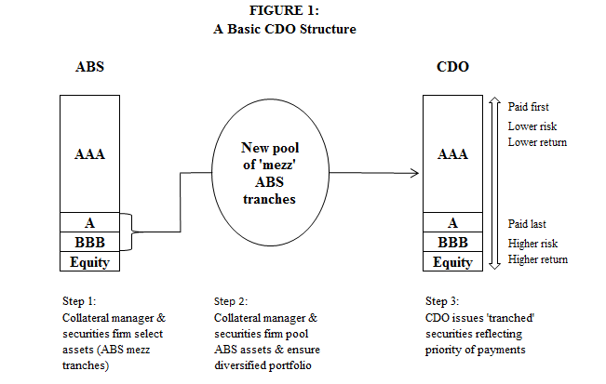

Source: derived from Financial Crisis Inquiry Commission (2011)

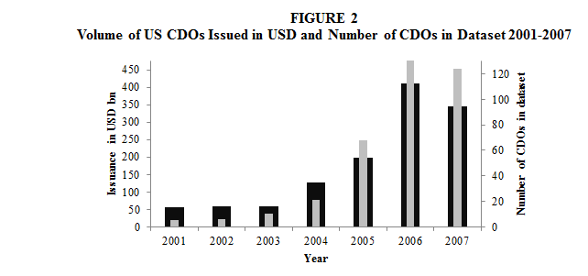

Source: SIFMA 2016 and Authors’CDO Database

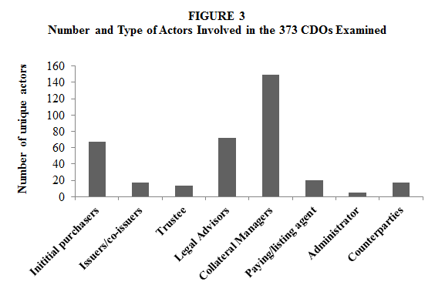

Source: Own calculations, from Authors’ CDO database

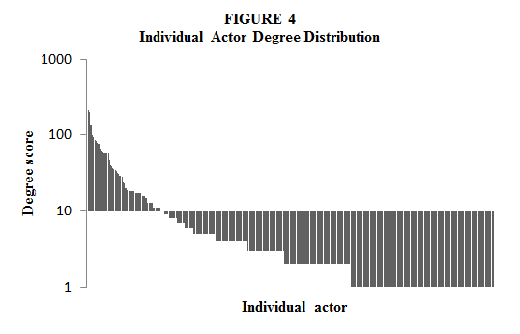

Source: Own calculations, from Authors’ CDO database

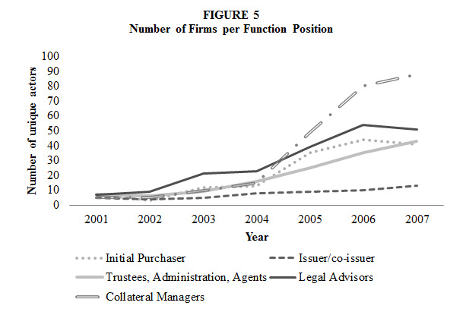

Source: Own calculations, from Authors’ CDO database

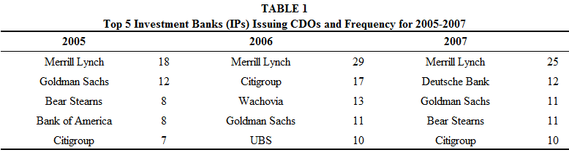

Source: Own calculations, from Authors’ CDO database

**FIGURE 6:**

**Comparison of Network Similarity Across Years 2001-2008**

Note: Correlation of individual matrices for years 2001 to 2008 in UCINet displayed through multidimensional scaling; line thickness = strength of correlation

Source: Own calculations, from Authors’ CDO database

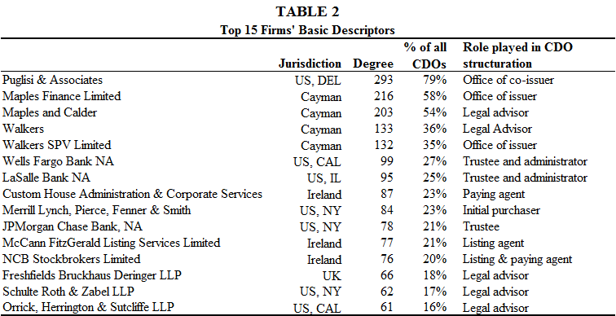

Source: Own calculations, from Authors’ CDO database

**FIGURE 7:**

**Core-Periphery Structure for the Total Network 2001-2008**

Note: white squares = core members; grey squares = periphery

Source: Own calculations, from Authors’ CDO database

**FIGURE 8:**

**Core-Membership Network Evolution 2001-2008**

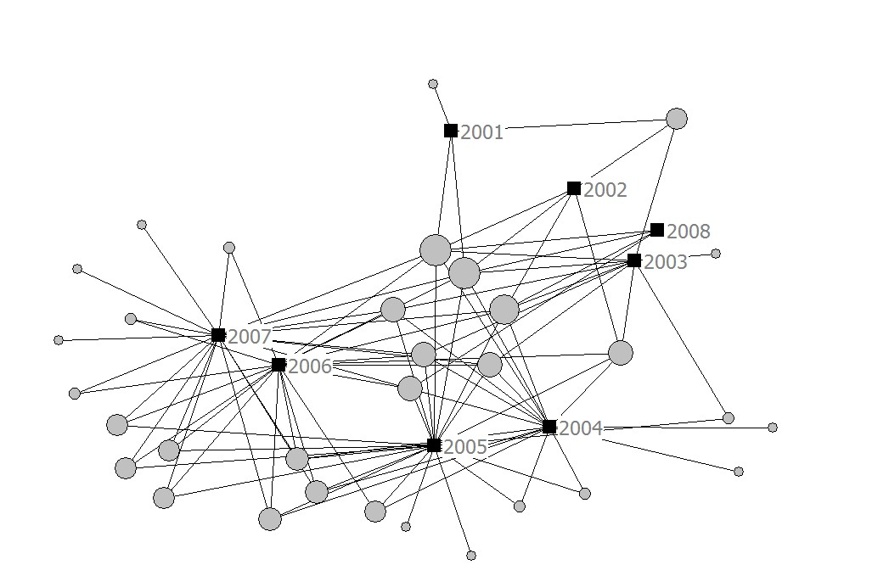

Note: Size of node represents overall core membership (nmax=8)

Source: Own calculations, from Authors’ CDO database

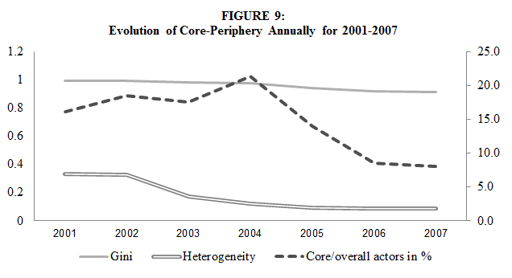

Source: Own calculations, from Authors’ CDO database

1. Here we use the term ‘activity formation’ rather than the more traditional ‘market formation’ to distinguish it from the later discussion of markets as an organizational form.
2. By role we mean defined activities required in the structuration process of CDOs. We use this term rather than use the terms ‘producers’ or ‘suppliers’, ‘buyers’ or ‘sellers’ which are more associated with market-based forms of organization and encourage a view of production through the linear, sequential stages of the transformation process. This is particularly relevant in the case of CDOs where many activities are performed contemporaneously.
3. Here we are using the terminology of the industry: the perceived ‘asset risks’ could be separated from the assets themselves and transferred synthetically using swaps. There were tax and capital advantages to using swaps rather than having a ‘true sale’ of assets.
4. A tax levied on interest or dividend paid to a legal person not resident in the country; this tax is deducted at source
5. This is best exemplified in Goldman Sachs’ legal defence against ACA, the collateral manager selected by Goldman for the CDO ‘ABACUS 2007AC-1’, who also invested in that CDO. ACA claimed it had been misled by Goldman about the involvement of the Paulson and Co hedge fund in the CDO. ACA presumed Paulson was an equity investor in CDO when in reality he shorted it. Goldman’s lawyers noted that ACA had previously worked on the CDO ‘ACA Aquarius 2006-1’ where the hedge fund Magnetar played a similar role to Paulson, and so should have been aware of such risks because they were ‘highly sophisticated institutions that were knowledgeable about subprime securitization products and had both the resources and the expertise to perform due diligence’. i.e. they understood the rules of the game.